भारत सरकार GOVERNMENT OF INDIA

वित्त मंत्रालय MINISTRY OF FINANCE

राजस्व विभाग DEPARTMENT OF REVENUE
केन्द्रीय अप्रत्यक्ष कर और सीमा शुल्क बोर्ड

CENTRAL BOARD OF INDIRECT TAXES AND CUSTOMS
सीमा शुल्क संयुक्त उप आयुक्त का कार्यालय
OFFICE OF THE DEPUTY COMMISSIONER OF CUSTOMS

एयर कारगो कॉम्प्लेक्स, अंतर्राष्ट्रीय हवाई अड्डा, नेडुंबाश्शेरी, कोचिन-683111

AIR CARGO COMPLEX, INTERNATIONAL AIRPORT

NEDUMBASSERY, COCHIN – 683 111

Website: www.cochincustoms.gov.in Ph: 0484-2611266
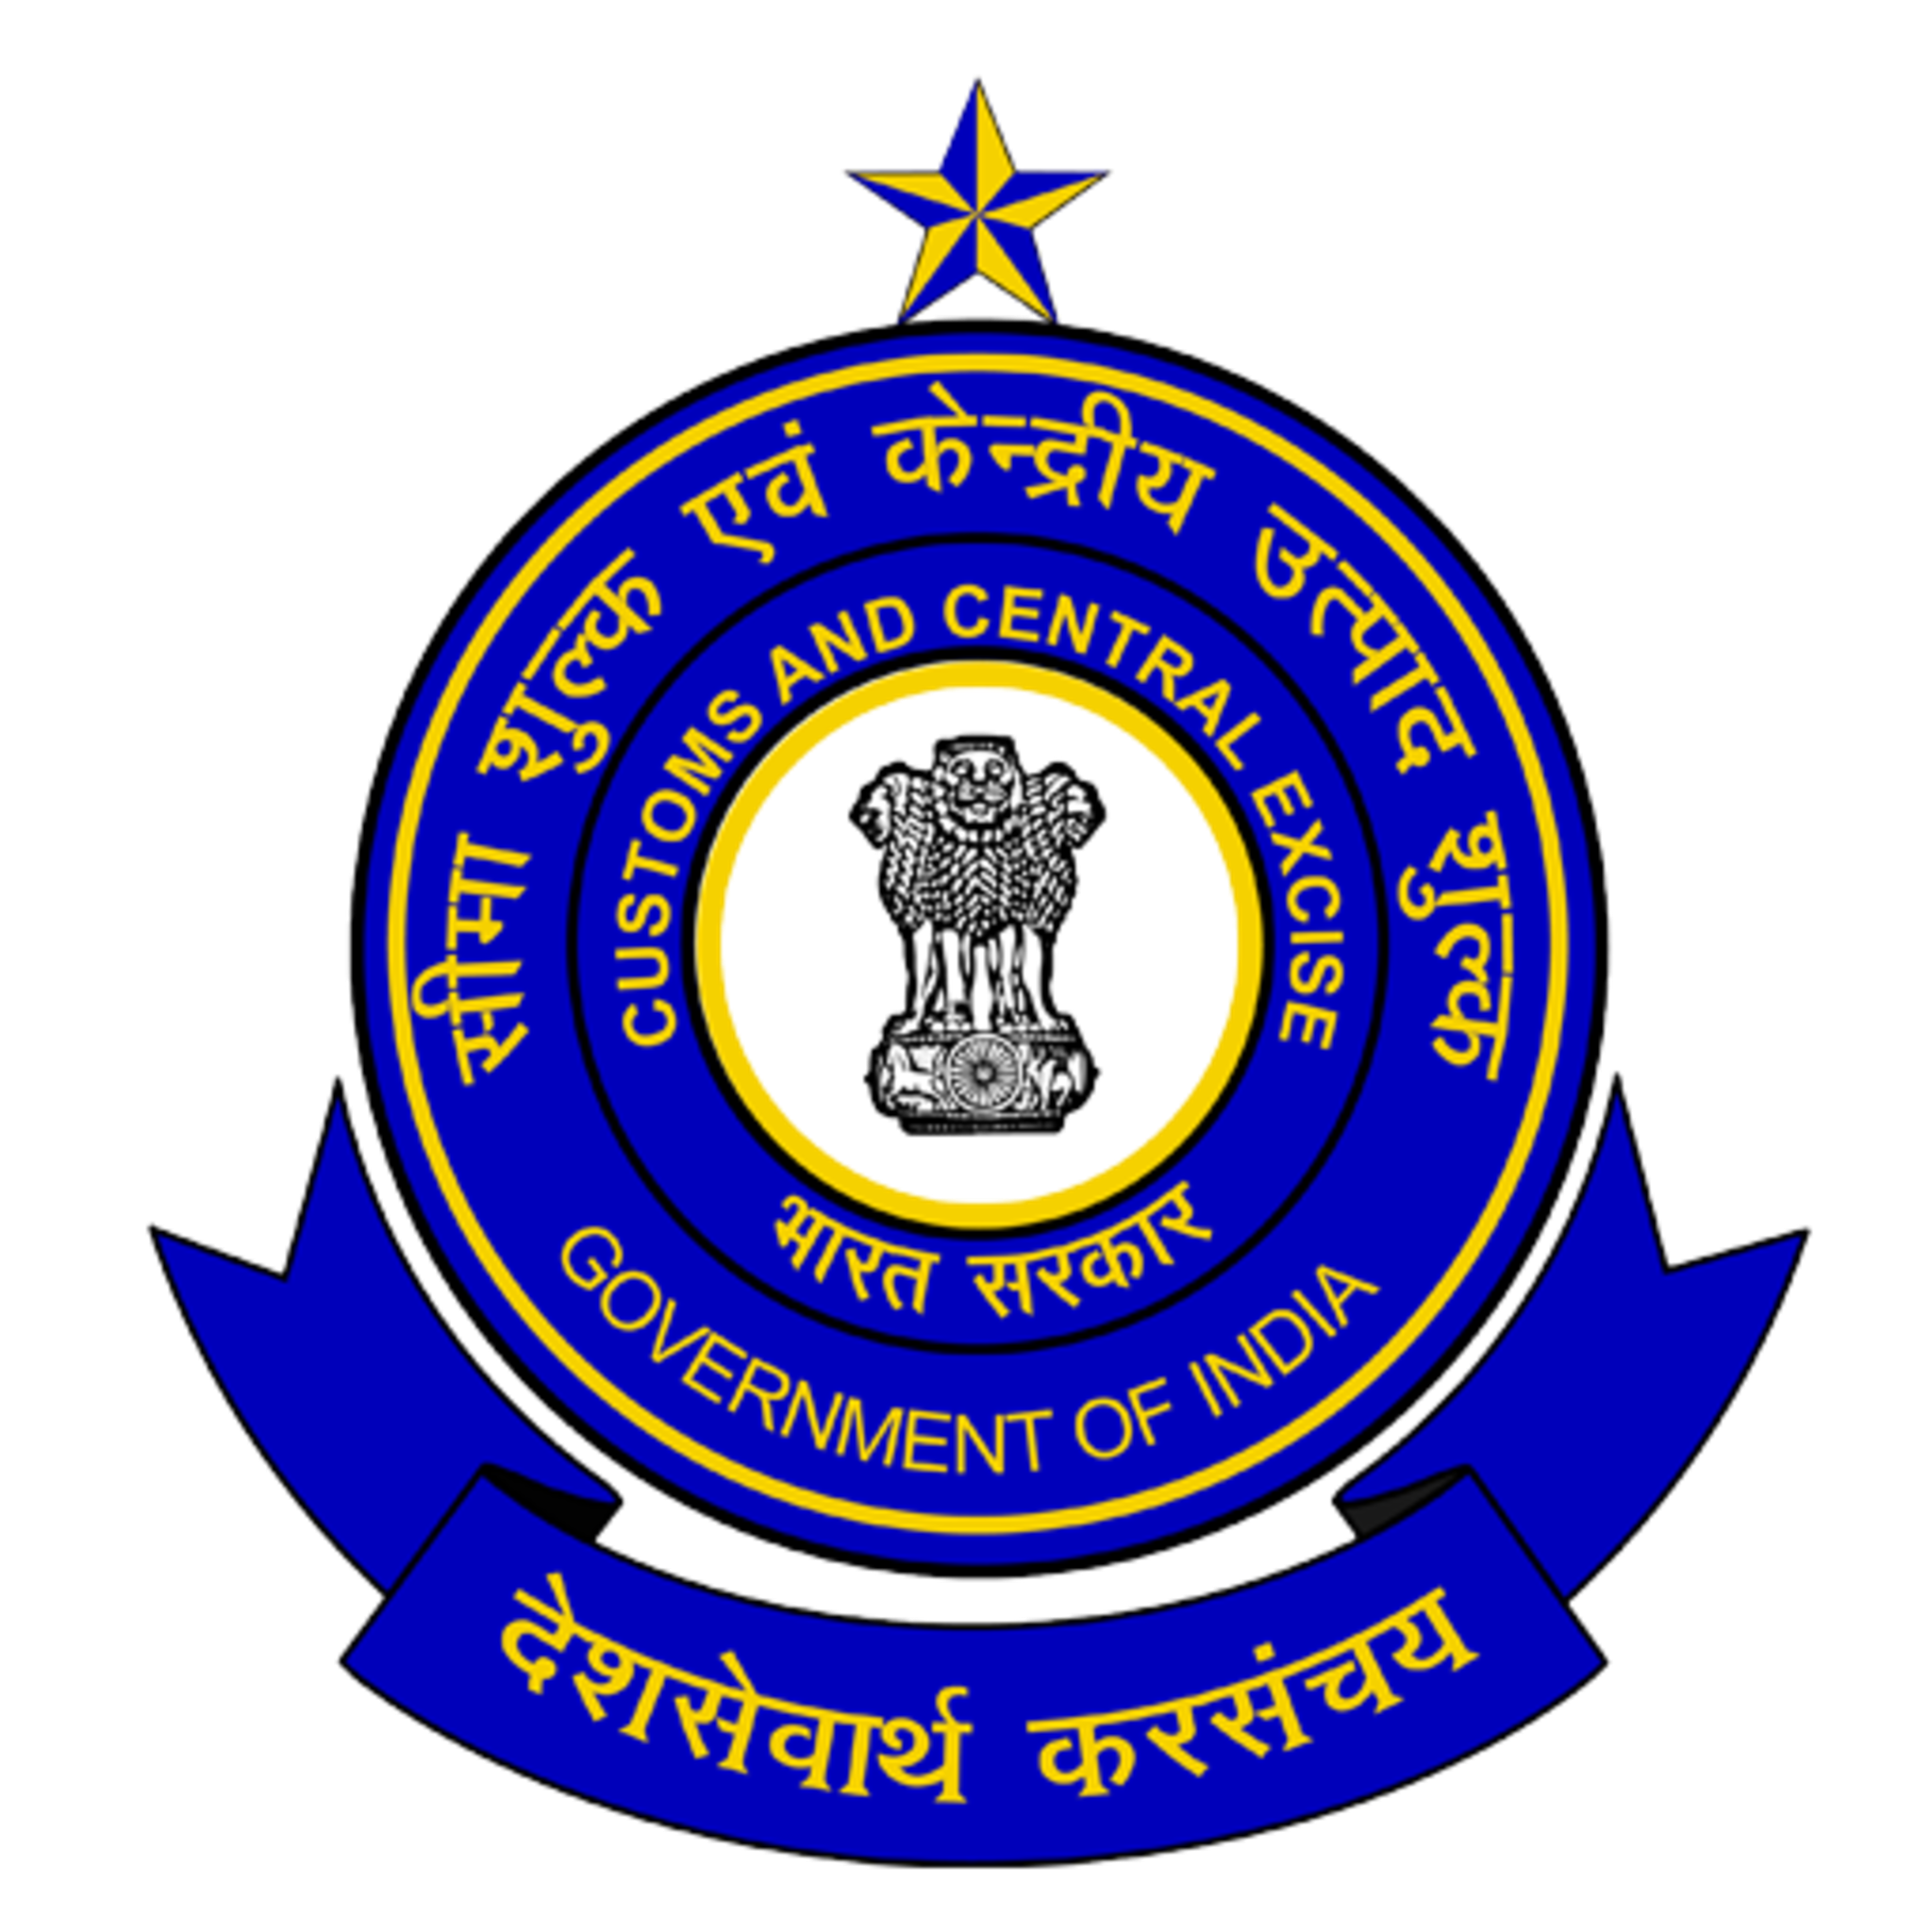

E-mail: acc@cochincustoms.gov.in Fax: 0484-2610099
F.No. S25/19/2013 PT VII- ACC.Cus Date: 03.03.2026

To,
The Deputy / Assistant Commissioner of Customs (Bond),
Cochin Special Economic Zone,
Kakkanad, Cochin, Kerala 682037

Sir,
Sub: Re-Warehousing of items received under Bond to Bond – Reg.
................
The following material received from the warehouse of Panchal PVT Ltd, plot No.SDF 4, (Part) Cochin Special Economic Zone, Kakkanad, Cochin, Kerala 682037 and deposited to the Special Warehouse of M/s. CIAL Duty free and Retail Services Limited XI 318E, Cochin International Airport Building, Kochi Airport- 683111.
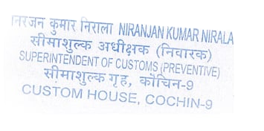
BOE No. | BOE Date | Item Description | Sub Bond No. | Sub Bond Date | Sub Bond Date2
2001112 | 16-09-2025 | JUICE | 533 | 25-09-2025 | 15
2001116 | 17-09-2025 | MINERAL WATER | 534 | 25-09-2025 | 275
2001133 | 22-09-2025 | FOOD | 535 | 25-09-2025 | 94
2001225 | 13-10-2025 | FOOD | 540 | 21-10-2025 | 34
2001408 | 25-11-2025 | FOOD | 552 | 28-11-2025 | 123
2001406 | 25-11-2025 | MINERAL WATER | 554 | 05-12-2025 | 365
2001431 | 03-12-2025 | FOOD | 553 | 05-12-2025 | 35
2001473 | 15-12-2025 | JUICE | 558 | 18-12-2025 | 20
2001477 | 16-12-2025 | FOOD | 556 | 18-12-2025 | 35
2000066 | 15-01-2026 | MINERAL WATER | 573 | 27-01-2026 | 350
2000155 | 03-02-2026 | FOOD | 577 | 16-02-2026 | 80
2000226 | 19-02-2026 | NUTS | 578 | 24-02-2026 | 42

Yours faithfully

SUPDT. OF CUSTOMS (ACC-BONDS) सीमा शुल्क अधीक्षक

Copy to. M/s CIAL DUTY FREE AND RETAIL SERVICES LIMITED, Nedumbassery........for information.

